ITIS 4250 / 5250

Shivani Sathe

Lab # 5

2nd November 2021

**Overview:**

On October 30, 2021, Detective Angela Lansbury handed me a case file along with two logical images MonarchIMG2021.E01, ClarionIMG.E01 and two sets of registry files- Registry M, Registry C. The files were from a hotel lobby computer which were provided on consent and from a computer belonging to the subject- Super Villain Monarch. Monarch had provided his busted laptop to Conjectural Technologies for repairs. Their technician, Pete White, alerted law enforcement to suspicious activity and acquired his laptop on behalf of officers with a warrant.

The investigating officer of case, Agent Sampson, had asked me to examine these files and provide records of communication regarding email conversations in which the Monarch has discussed ways to cause harm to local super scientist Dr. Thaddeus Venture and identify any communications with the GCI, the location of members of the GCI, photographs of the Monarch and his associates, communications with the GCI or any evidence of explosives, drones, poisons, bombs or other means to kill or injure the Monarch’s intended targets.

**Forensic Acquisition & Exam Preparation**

To begin the analysis, Windows 10, 64-bit system was used. The two forensic image files MonarchIMG2021.E01and ClarionIMG.E01 were placed in a newly created folder named ‘**Lab 5**’ on desktop. Later, AccessData FTK Imager 4.5.0.3 was used to verify the MD5 hash value of both the images before starting the analysis and also at the end of the analysis.

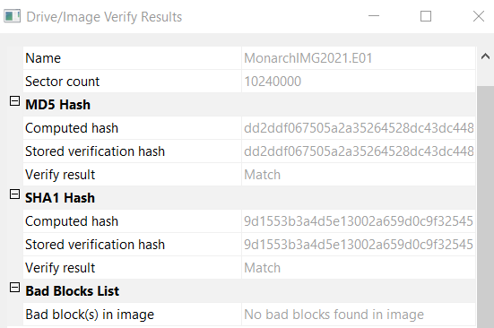 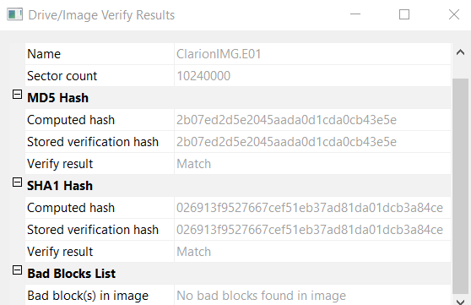

*Verification of images before analysis*

**Software used for the task:**

1. Windows 10 operating system

2. Access Data FTK imager for image verification

3. Autopsy

4. Photorec – (to recover image files from a forensic image)

5. Cain & Abel to crack passwords

6. PRTK Password recovery toolkit (To find password of files)

7. Reg Ripper for getting last login time (To explore registry files)

8. Registry Explorer for getting last used software

In Autopsy, a new case was created and MonarchIMG.E01 file was loaded as the data source.

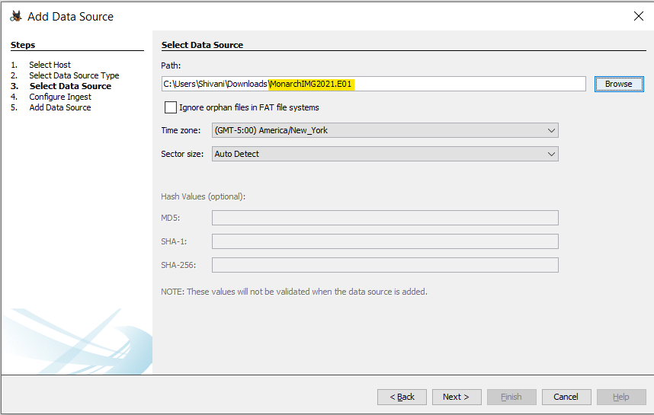

All Ingest Modules were selected.

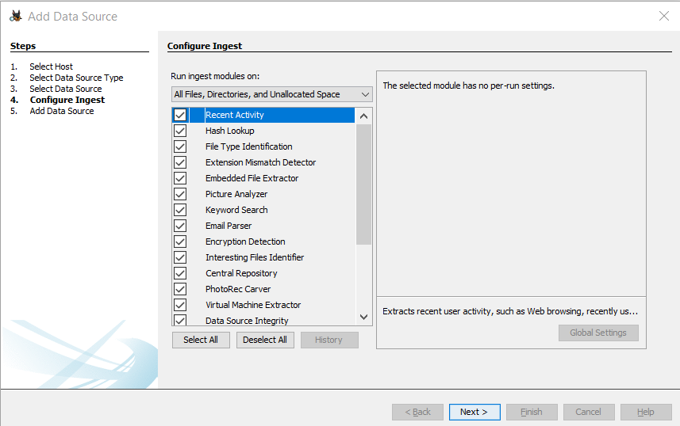

Similarly, ClarionIMG.E01 was added as data source and all the ingest modules were selected. Once all the modules ran, analysis results were seen.

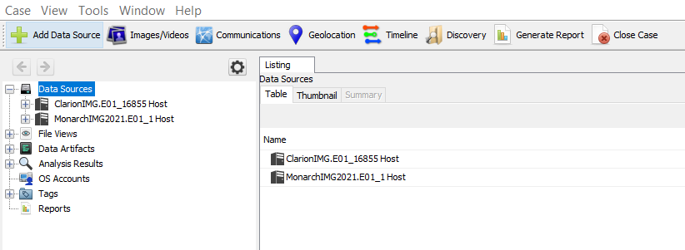

To recover the pictures using PhotoRec, the image files were mounted using AccessData FTK Imager by right clicking on MonarchIMG2021.E01 and ClarionIMG.E01in turn, Image Mounting -> Mount

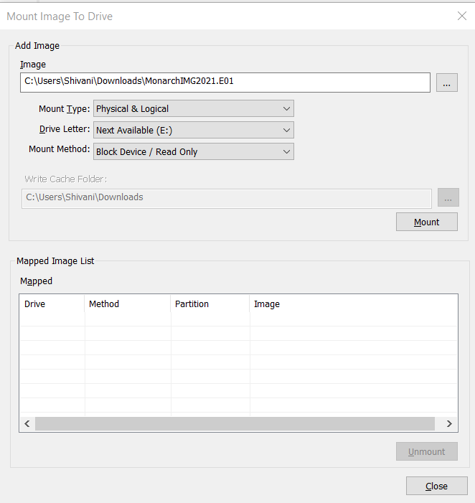 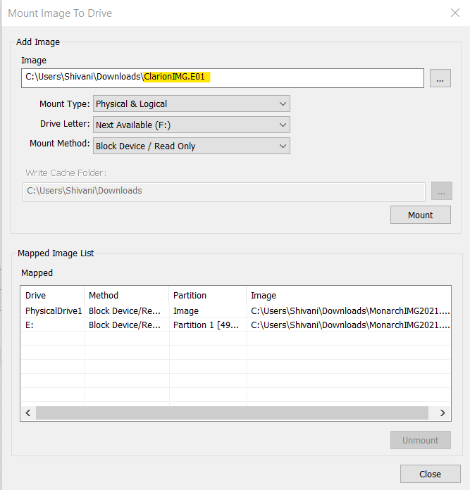

*Mounting Monarch Image Mounting Clarion Image*

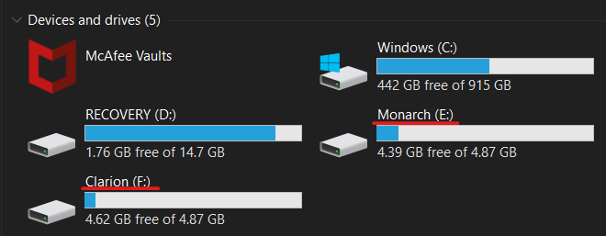

*Both Images mounted successfully*

PhotoRec software was run, and Monarch disc was selected. The destination folder was chosen to be Lab 5 to store the recovered pictures which was created on the desktop initially.

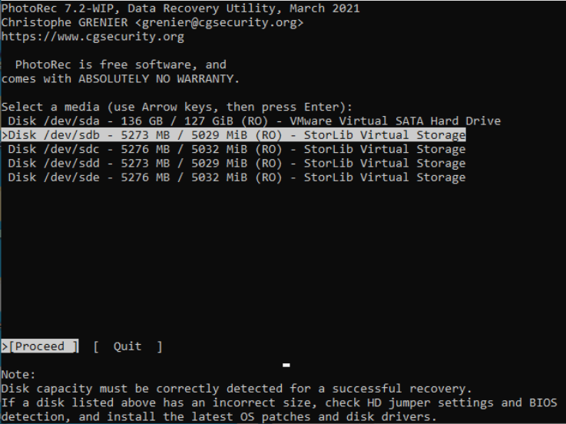

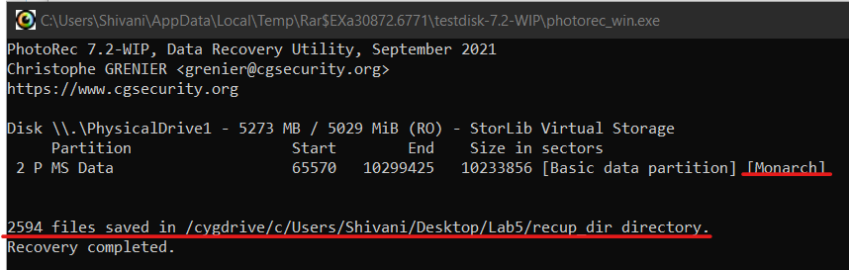

*Recovery of pictures done and stored in chosen folder*

**Findings and Report (Forensic Analysis)**

1. ***Was there communication from someone claiming to be the Guild's operative, or can you identify the operative?***

An email communication from the operative was found in following path; Data Artifacts 🡪 Email Messages 🡪 Default 🡪 Default

The emailcommunication was from **Hamilton J Fantomos, The Phantom Limb** with mail address‘generalconsolidatedindustries@aol.com’ congratulating Monarch that his application is received by the governance body operating Guild of Calamitous Intent and granting him arching rights 3rd class.

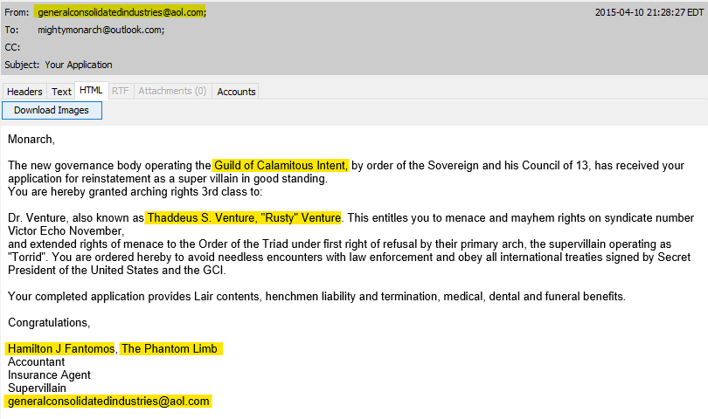

*Guild Operative Mail*

1. ***Can you identify any pictures of this person?***

Yes, an email communication from the operative **Hamilton J Fantomos, The Phantom Limb** was found in path Data Artifacts 🡪 Email Messages 🡪 Default 🡪 Default.

The mail mentioned “I was with Sheila.” and had below picture as an attachment. This could represent the person in the picture was the operative.

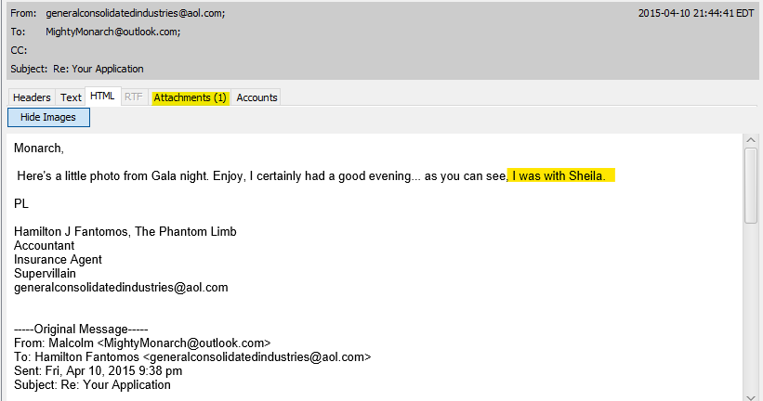

*Email from Operative*

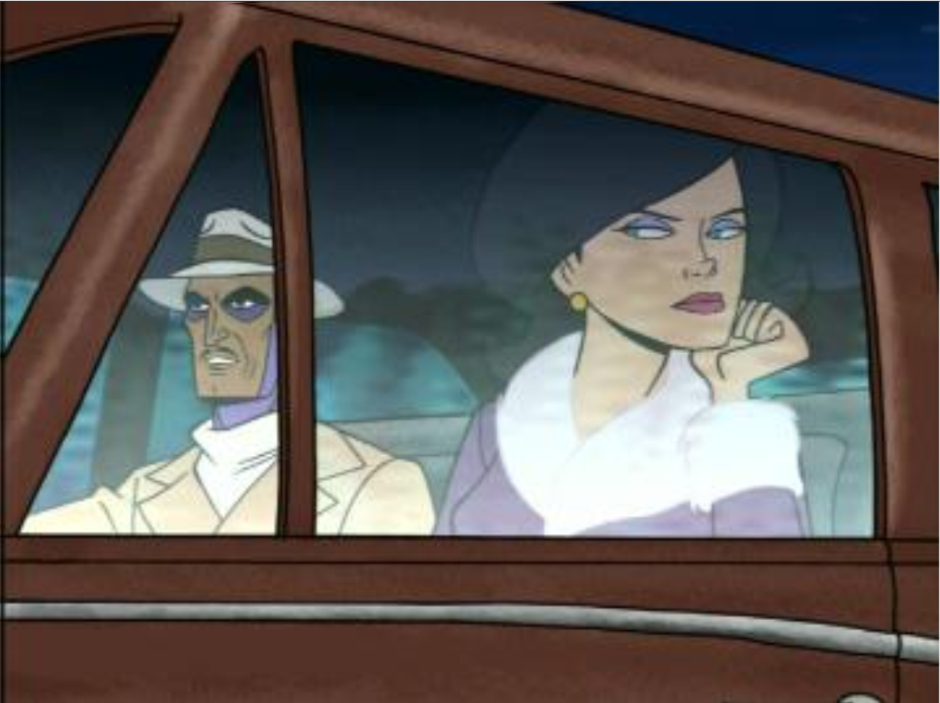

This could be the operative possibly

*Picture in Email Attachment*

1. ***Can you provide any pictures depicting the Monarch?***

Yes, couple of emails were found, which contains animated character from Venture-bros tv show as seen in below screenshots. In another email, with Subject “Recruitment” the Monarch is talking about the recruitment poster they made which contains same animated character as in first mail. This could depict that Monarch may be interested in this show.

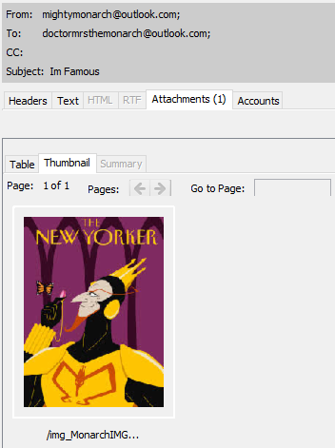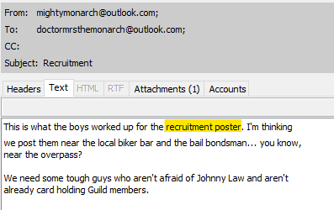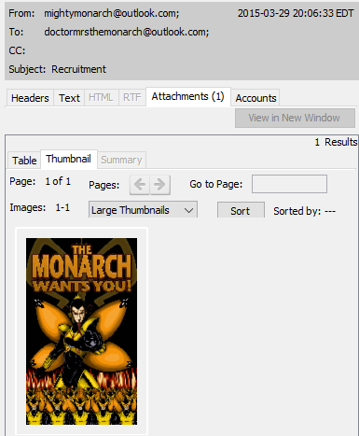

Using Photorec to recover files, few pictures of people cosplaying the character in above attachments was found, this could be Monarch.

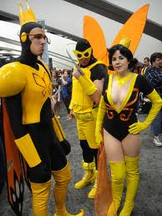 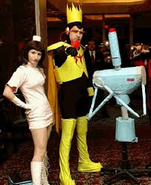 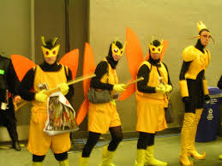*Pictures suspected to be of Monarch*

1. ***Can you find the Monarch's email address or the email address of the operative?***

Yes, using Autopsy email address of Monarch and that of the operative was found in following path; Data Artifacts 🡪 Email Messages 🡪 Default 🡪 Default

Multiple emails as seen in below screenshot were observed to be sent from ‘**mightymonarch@outlook.com**’ and also received to the same email address where the sender is seen addressing it the Monarch.

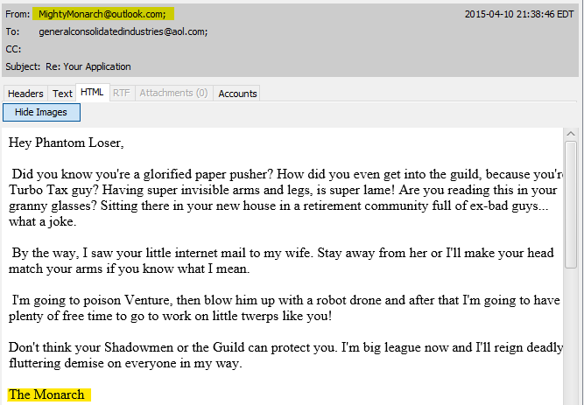 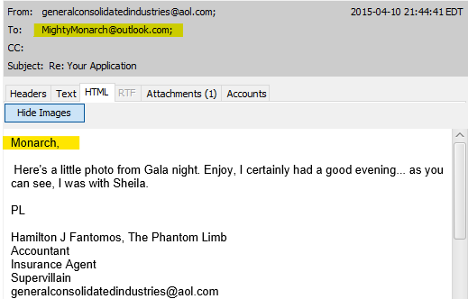

*Sender addressing to Monarch on same email address on same mail thread*

*Response from the Monarch to his application submitted to Guild Calamtious Intent*

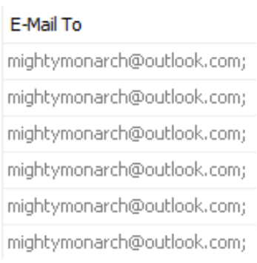

*Email address of the Monarch*

*from Autopspy*

There is an email communication from someone congratulating the Monarch of being accepted to the Guild of Calamitous. This could be from the operative from the Guild. The name of the person is **Hamilton J Fantomos, The Phantom Limb** and the email address is ‘**generalconsolidatedindustries@aol.com**’.

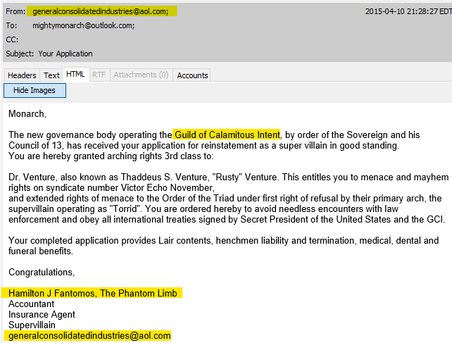

*Guild operative email address*

1. ***Are there any items related to the Monarch's plans for violence?***

Yes, items were found related to Monarch’s plans of violence. Using Autopsy, below Web search results were found which could be related to his plans of violence. The items were at the following path; Data Artifacts 🡪 Web Search 🡪 WebCacheV01.dat

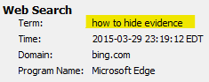 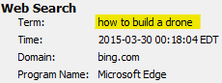 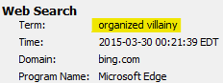

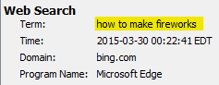 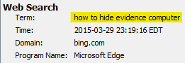

An email was found at path Data Artifacts 🡪 Email Messages 🡪 Default 🡪 Default

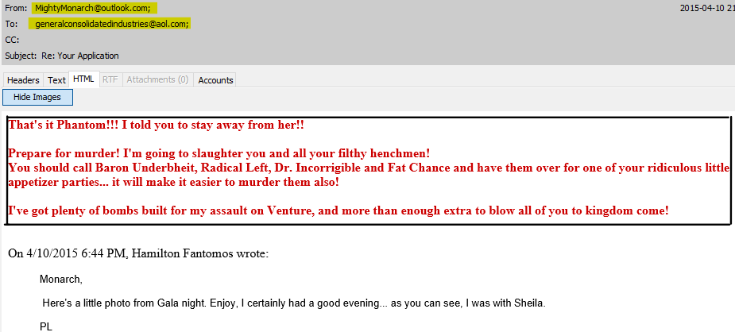

Below images were found at location -/img_MonarchIMG2021.E01/vol_vol2/Users/Malcom/AppData/Local/Microsoft/Windows/Temporary Internet Files/Low/Content.IE5/KBIPEE3F/

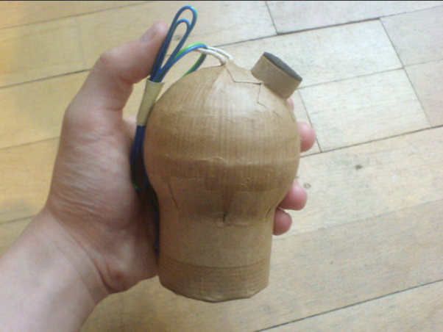 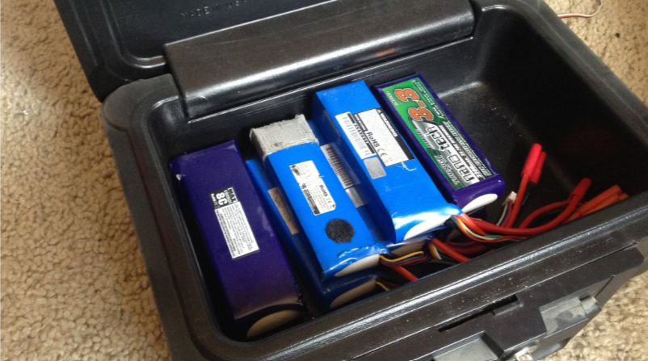

Also, there was an encrypted file named **AllMyPlans.zip** observed under Analysis Results 🡪 Encryption Detected

To decrypt it, AllMyPlans.zip file was extracted from Autopsy and loaded in AccessData Password Recovery Toolkit.

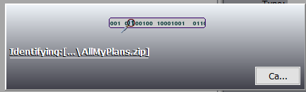

*Tool analyzing the file*

Automated ZIP Dictionary Attack was executed on the file

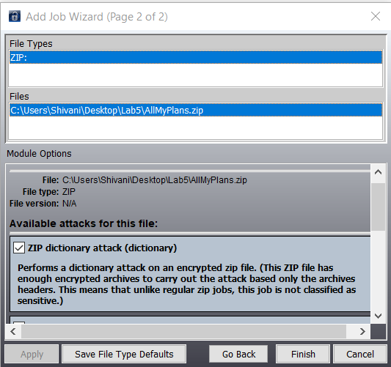

Password was cracked successfully, password is “monarch”

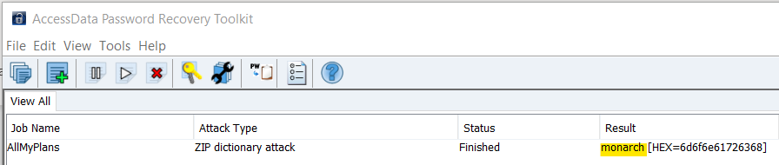

Using the above cracked password, below are the contents of AllMyPlans.zip file which serve as proof of Monarch’s plans of violence:

1. PDF File on ‘How to Build Your Own Drones’

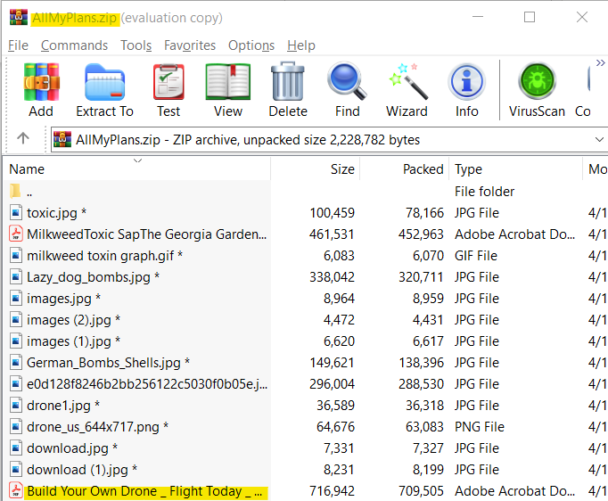

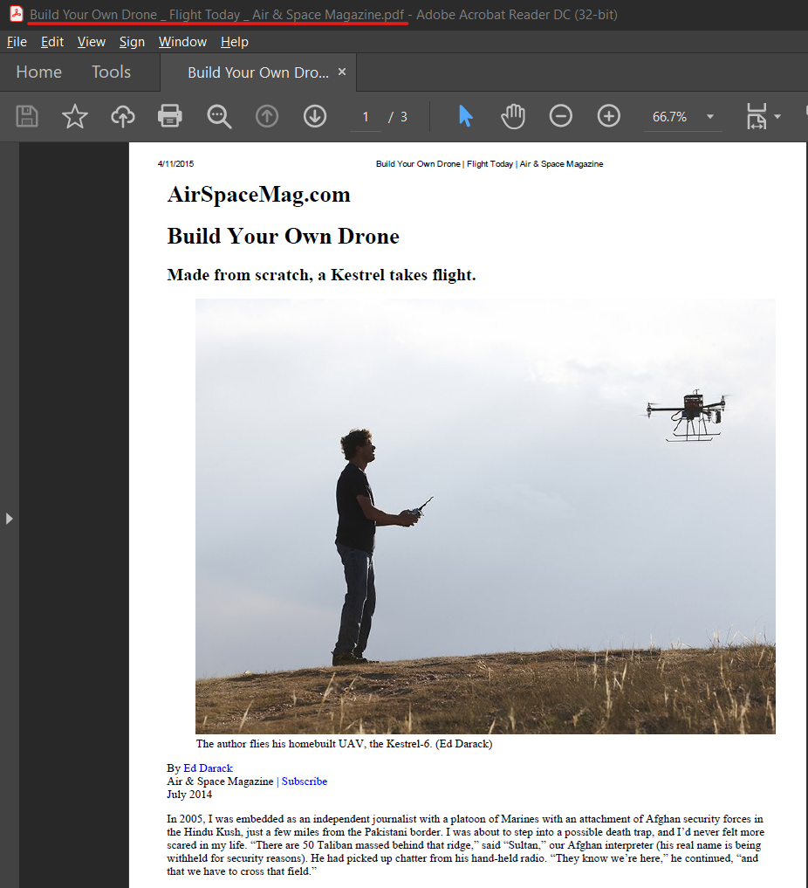

1. Pictures of the drones

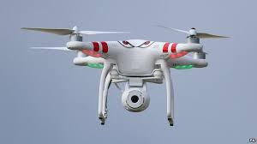 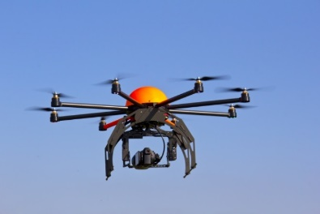

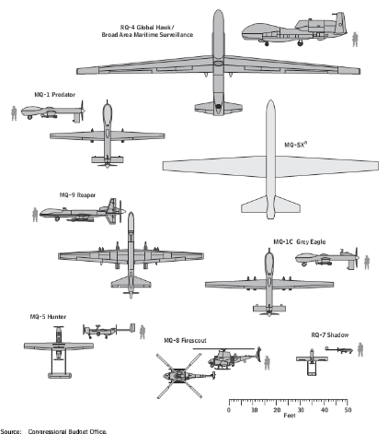

1. Pictures of different types of bombs

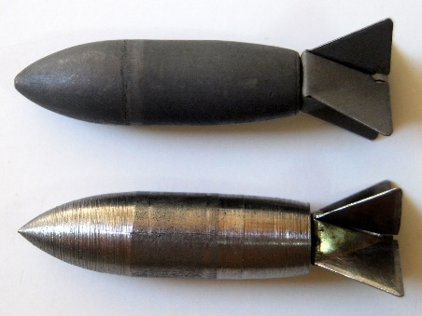 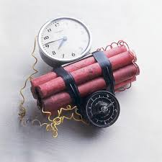 

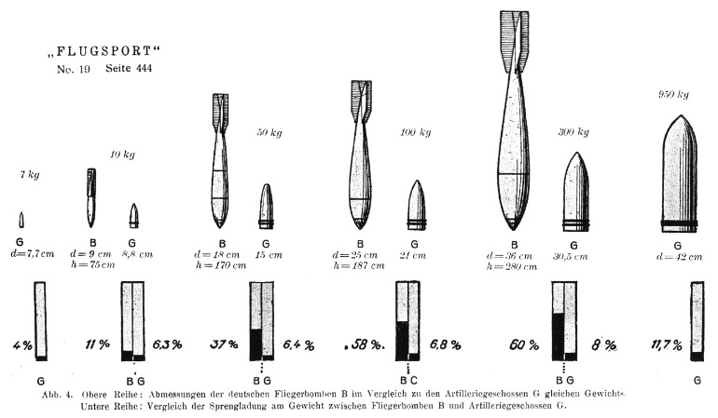 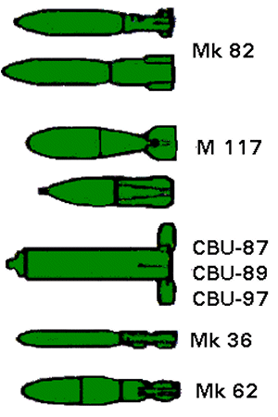

1. A PDF file and a picture containing detailed explanation on Milkweed toxic Plant. A map is also found regarding different types of Milkweed in different areas.

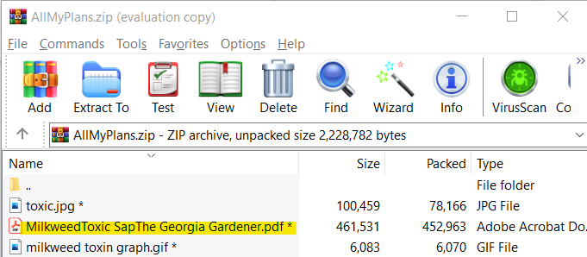 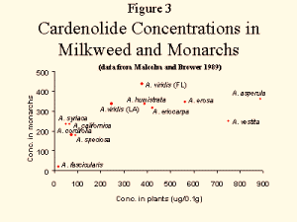

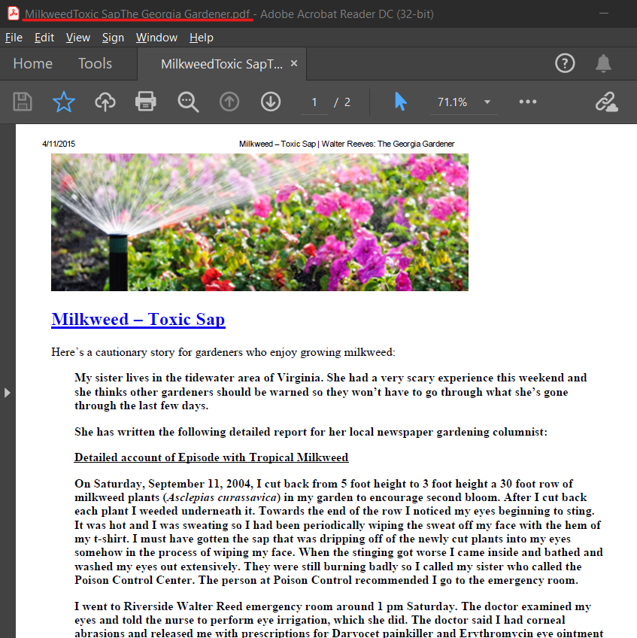   
 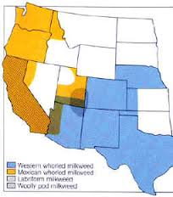

1. Picture of a poison

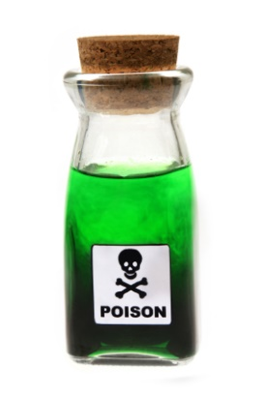

1. Pictures of Poisonous plants



1. ***Can you recover any passwords?***

Yes, the passwords for the following were successfully recovered-

1. AllMyPlans.zip file
2. Monarch Login
3. Clarion Login

AllMyPlans.zip file password was cracked successfully by using AccessData Password Recovery Toolkit. The password was **‘monarch’.**



In Autopsy, the login details of system belonging to Monarch and the login details of hotel lobby computer were found in following path; File Views - File Types - By Extension - Images, view by Thumbnails instead of Table. There were two images with Host Names ‘IE11WIN7’ (From MonarchIMG2021.E01) and ‘CLARIONRICHMOND’ (From ClarionIMG.E01), with both passwords as ‘**Passw0rd!**’

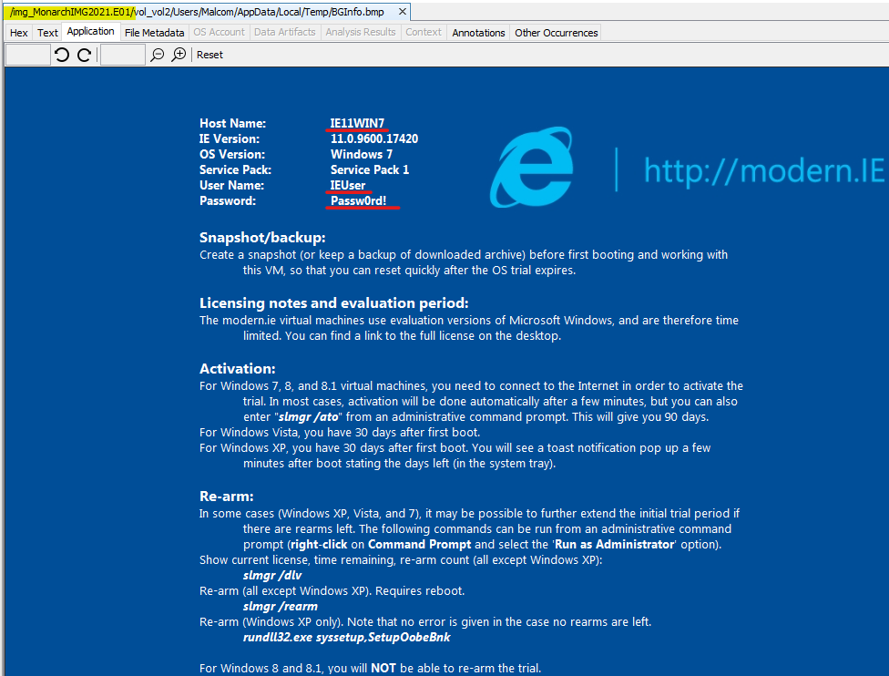

*Password Picture from MonarchIMG2021.E01*

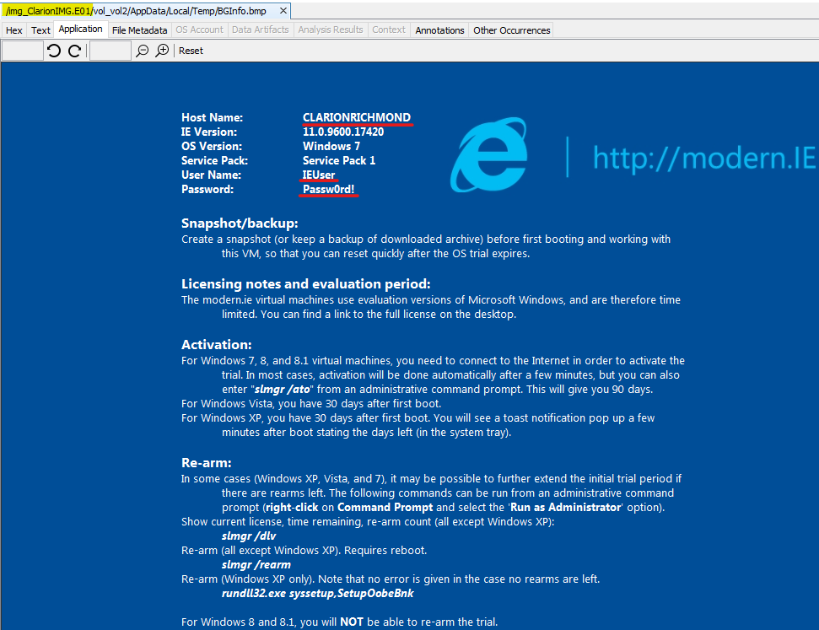

*Password Picture from* *ClarionIMG.E01*

Above found credentials were validated using Cain and Abel for both images. Dictionary attack was carried out for password validation.

Hashes were imported from SAM Database of Registry M(Monarch) and Registry C(Clarion) and System file of Registry M and Registry C were used for boot key.

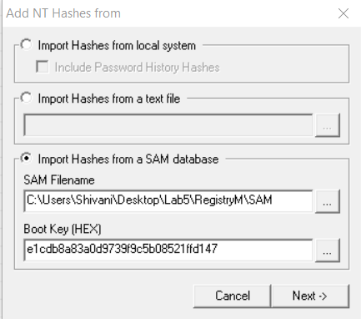

*Importing Hashes from Registry M*

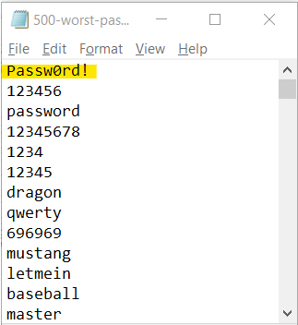 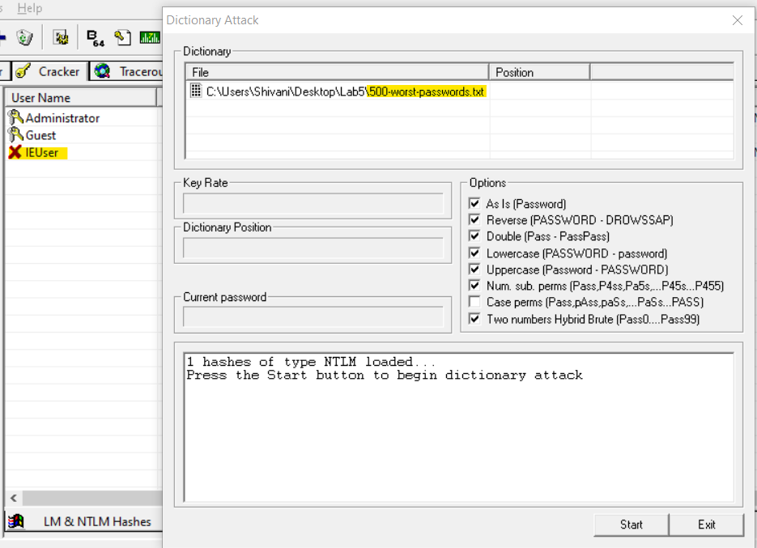

*Password found from Autopsy added List added to validate IEUser password*

*to the list*

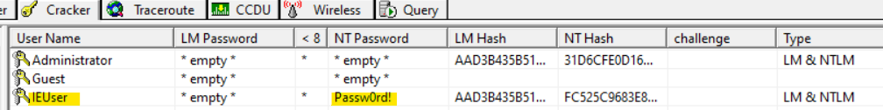

*Password cracked successfully*

Similar process was carried out for validating the password from ClarionIMG.E01 and it was successfully cracked.



*Password cracked successfully for ClarionIMG.E01*

1. ***What was the last time of login of the local user account?***

Last login from MonarchIMG is **March 29, 2015 at 23:09:54**

Last Login from ClarionIMG is **April 11, 2015 at 01:51:52**

RegRipper was used to find the last time of login. SAM file of RegistryM was loaded and a report file was created to log details.

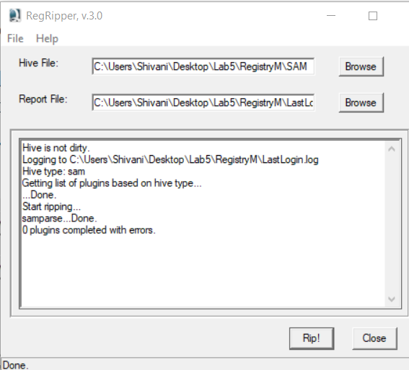 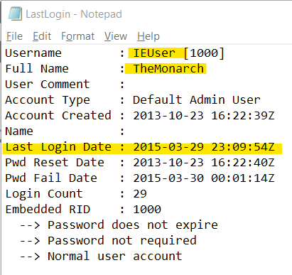

*SAM file ripped from RegistryM Last Login Time from RegistryM*

Similarly, the SAM file of RegistryC was loaded and ripped using RegRipper, and the last login date was found.

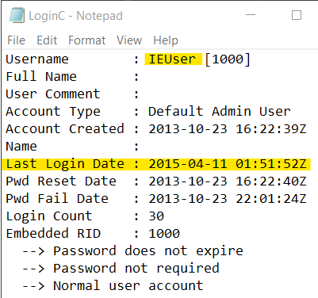

*--Last Login Time from RegistryC*

1. ***Can you find any map data or location searches?***

Yes, multiple web searches and pictures were found of various locations and map data. In Autopsy, under Data Artifacts 🡪 Web history, below searches were observed.



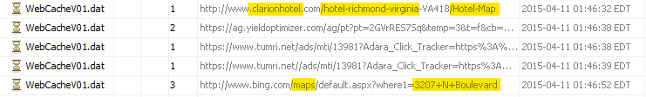

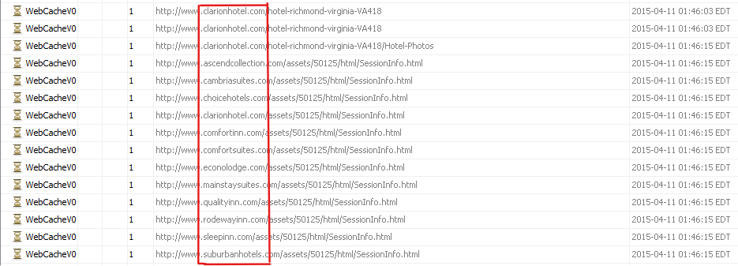

*Web Searches for hotels and other locations*

In Autopsy, under File Views – File Types – By Extension – Images, there were multiple map data and hotels pictures.

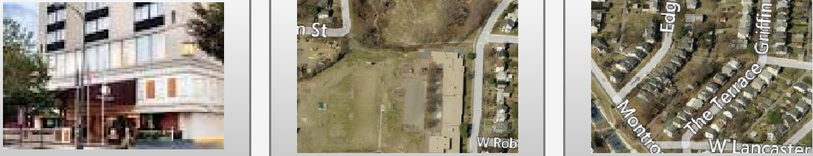

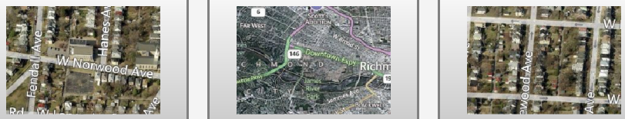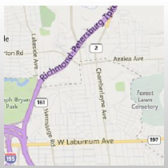

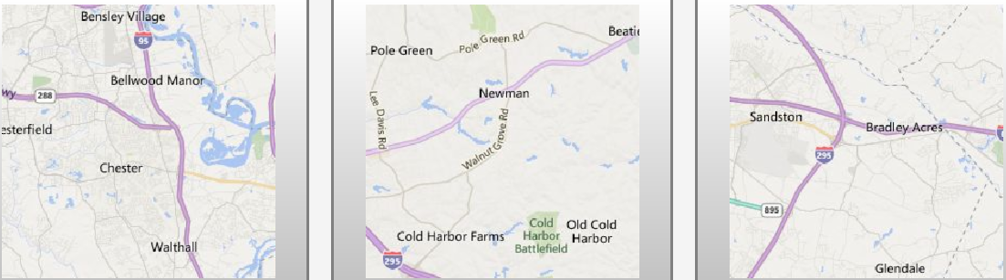

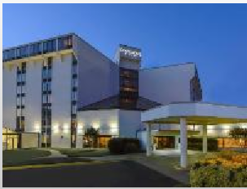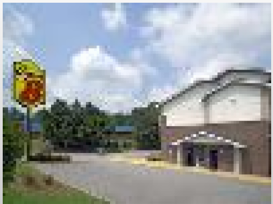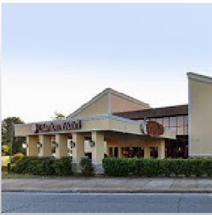

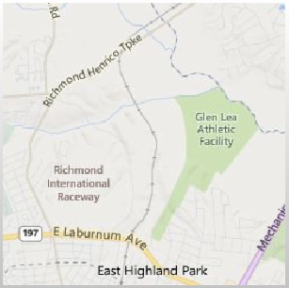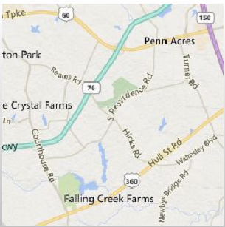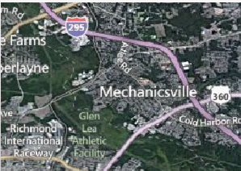

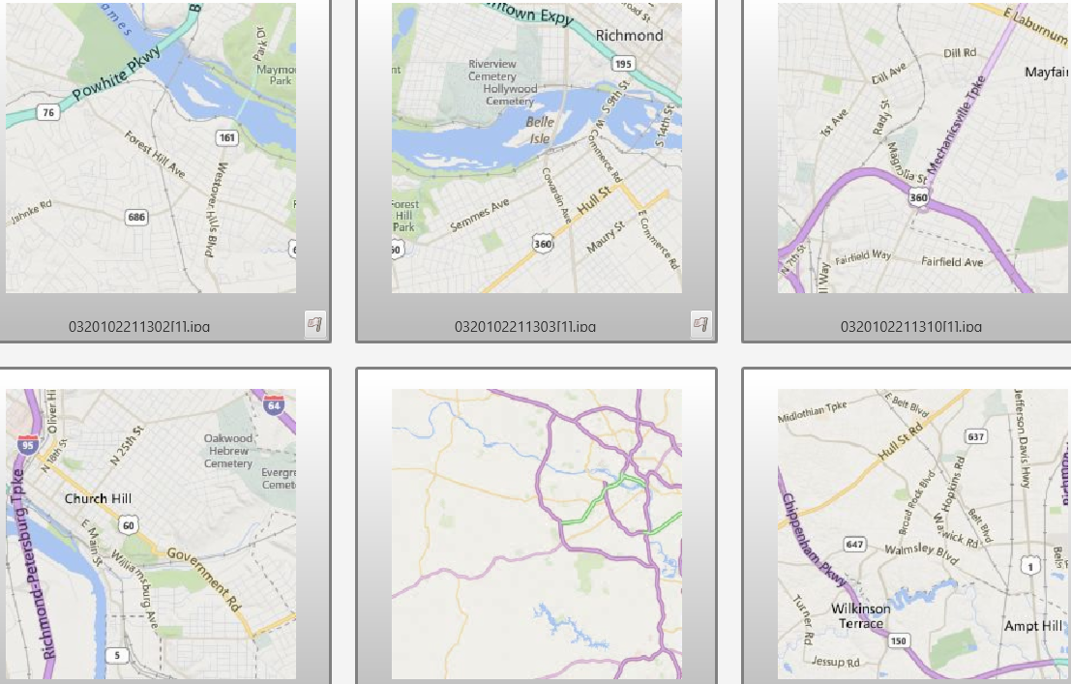

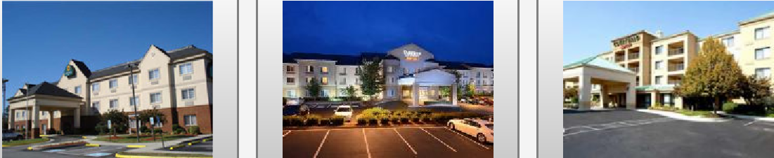

1. ***What were the most recent files in use?***

Below is the screenshot of the most recent files that were in use. From Autopsy, NTUSER.DAT file was extracted from the following location: /img_MonarchIMG2021.E01/vol_vol2/Users/Malcom/NTUSER.DAT

NTUSER.DAT file was loaded in Registry explorer and most recent files in use was found at CMI-CreateHive{6A1C4018-979D-4291-A7DC-7AED1C75B67C}\Software\Microsoft\Windows\CurrentVersion\Explorer\ComDlg32\LastVisitedPidlMRU

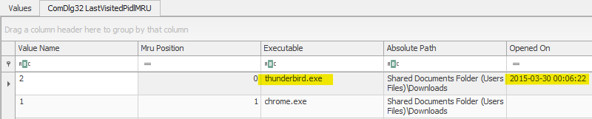

CMI-CreateHive{6A1C4018-979D-4291-A7DC-7AED1C75B67C}\Software\Microsoft\Windows\CurrentVersion\Explorer\ComDlg32\OpenSavePidlMRU

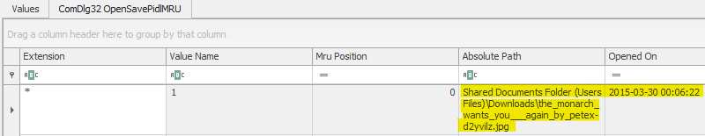

The Software Hive from Registry C was loaded in Registry Explorer and most recent file in use was found to be **thunderbird.exe as seen in below screenshot-**

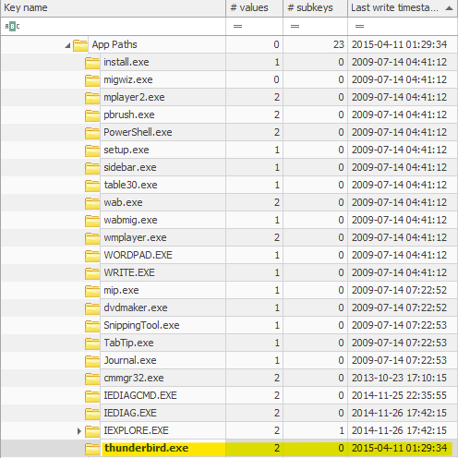

**Conclusion**

Overall, in this lab I was asked provide records of communication regarding email conversations in which the Monarch has discussed ways to cause harm to local super scientist Dr. Thaddeus Venture and others, identify any communications with the GCI, the location of members of the GCI, photographs of the Monarch and his associates, communications with the GCI or any evidence of explosives, drones, poisons, bombs or other means to kill or injure the Monarch's intended targets. To begin the analysis, the image was loaded using AccessData FTK Imager 4.5.0.3 on a Windows 10 Machine and the hash value of image was verified to conclude that it was not tampered before the analysis process. With the help of Autopsy, the provided images were examined and all the questions regarding this case were successfully answered. The image was again verified using AccessData FTK Imager to ensure it was not altered. No evidence has been retained. The forensic image, and answered questions regarding it, were returned to Detective Angela Lansbury.